Lab 4 Output and Answers

1. The simple tree model is easier to interpret than the random forest tree because there is less information for the simple tree output. Specifically, the simple tree model only has the fit statistics for that single tree while the random forest has the fit statistics for all the trees in it, which in this case was 100. For the simple tree I can read the ASE for that lone tree while for the random forest I have to go through how the ASE is changing throughout the model. Additionally, the variable importance chart for simple trees is easier to interpret because it has far fewer variables to go through than the random forest model.

The random forest is more accurate than the simple tree because the random forest has a lower average square error than the simple model.

**Simple Tree Model ASE = 9011.6**



**Random Forest Model ASE = 6210.65**



(Number 2 Continue to the Next Page)

2. The Out-Of-Bag testing set had a much larger error than the training set because the model is first fit to the training set and then tested on another set of data.



(Number 3 Continue to the Next Page)

3. After 3 trees, the model becomes more accurate than the simple tree model; however, I used 79 trees in my final model because it produced the lowest ASE where ASE=5562.52. After 79 trees, the ASE slightly rose again and stabilized around 5615**.** The ASE for the training model continued to decrease through 100 models, but the OOB testing model stopped decreasing after 79 trees. Using less than 86 trees produced models with higher ASE’s.

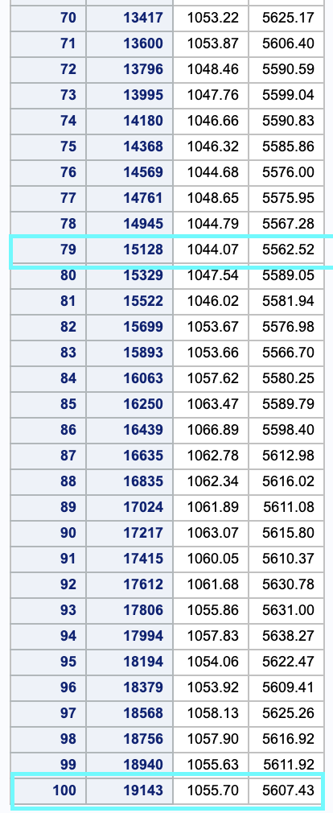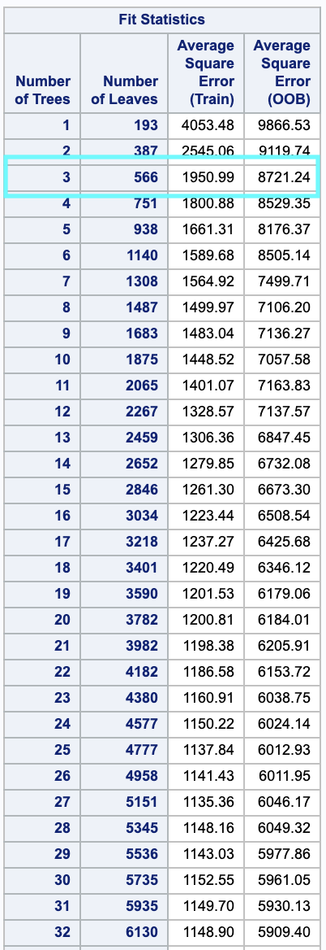

4. The model I used was set to 26 variables which produced the ASE=5562.52. When I reduced the number of variables to “16 variables to try” the model became more accurate with a lower ASE where ASE=5470.53. When I increased the number of variables to “46 variables to try” the model became less accurate because the ASE increased such that ASE=5737.2.

